Role/Rank Requirement Function

Role/Rank Requirement? Yes/No – With the ability to specify which or both

Role Requirement
Action Officer - With ability to specify which Action Officer
Branch Chief – With ability to specify which Branch Chief

Division Chief – With ability to specify which Division Chief
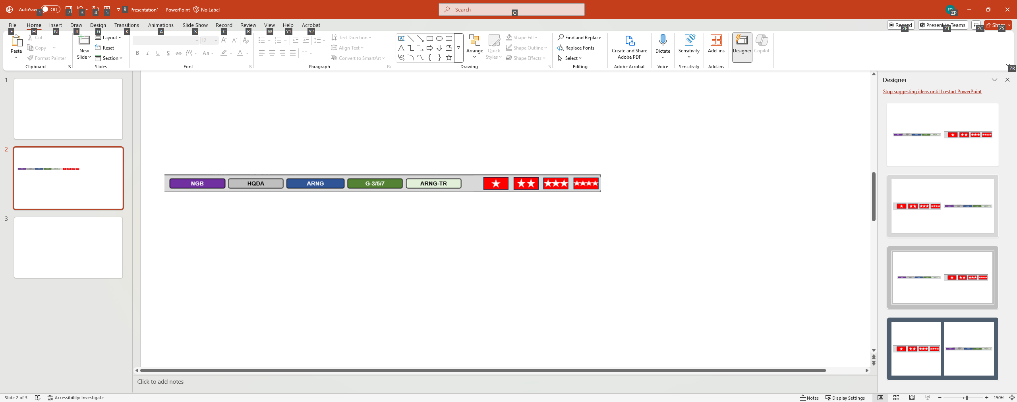
ARNG G3

ARNG G-3/5/7

DDARNG = Deputy Director Army National Guard

DARNG = Director Army National Guard
CNGB = Chief National Guard Bureau
Other (This could be someone else in the organization or Civilian Deputy or equivalent)


Rank Requirement:

O3 = Captain

O4 = Major

O5 = LTC or Lieutenant Colonel

O6 = COL or Colonel

O7 = BG or Brigadier General = one star

O8 = MG or Major General = two stars

O9 = LTG or Lieutenant General = three stars
O10 = General = four stars
Other (Could be GS government employee or SME which is Subject Matter Expert). This allows for a wide aray of different positions or high level government employee.

